**User Stories under EPIC:-**

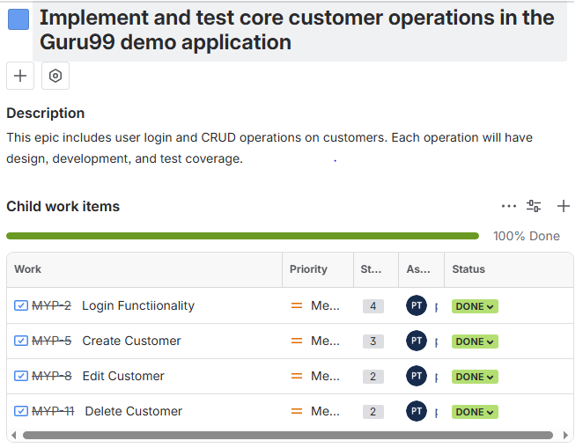

**TestCases for Login Feature:-**

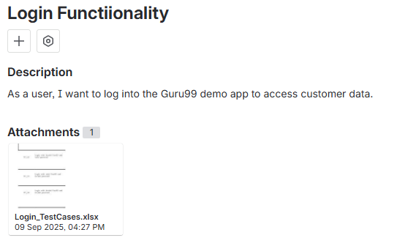

**Sub-Tasks for Login feature:-**

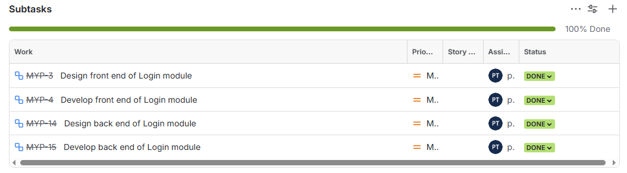

**Test-Cases and Sub Tasks for Customer Create module:-**

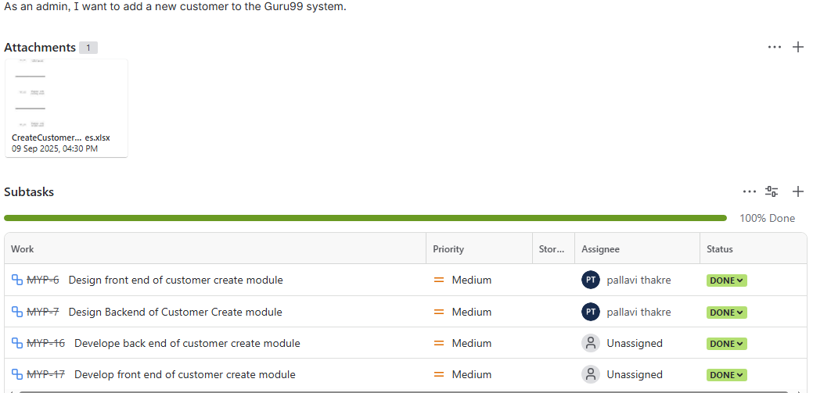

**Test Cases and Sub Tasks for Edit Customer:-**

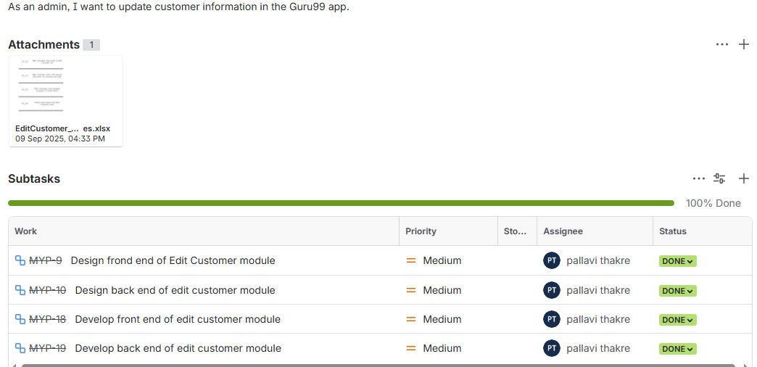

**Test Cases and Sub Tasks for Delete Customer feature:-**

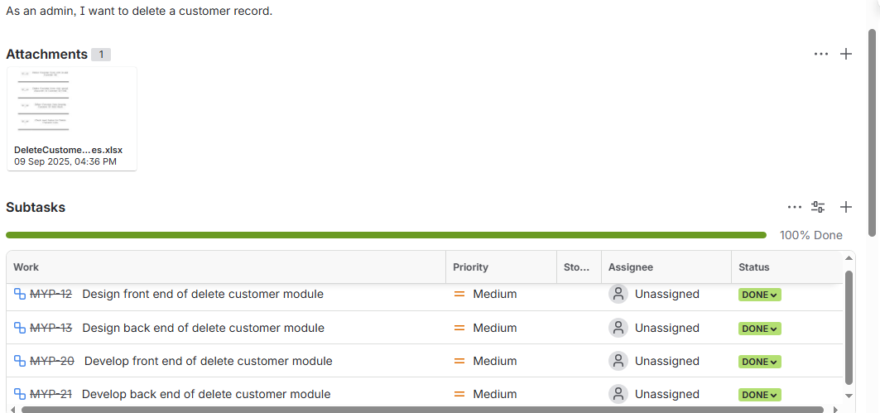

**User Stories in Sprint Backlog:-**

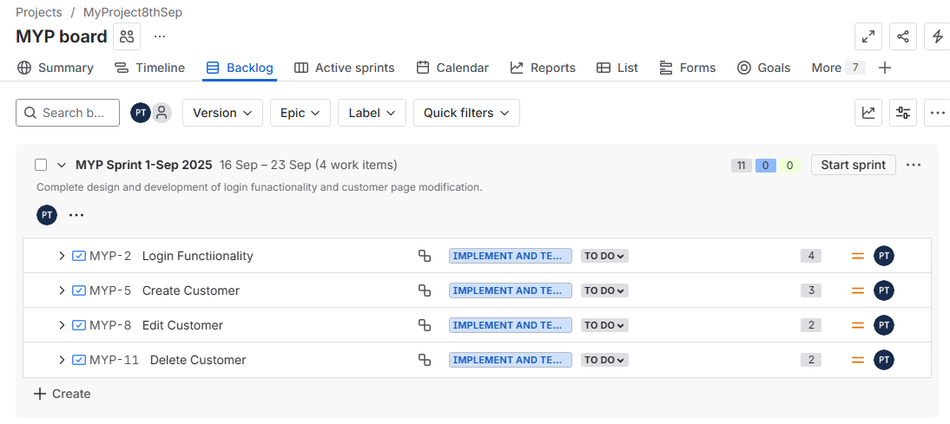

**Starting the Sprint:-**

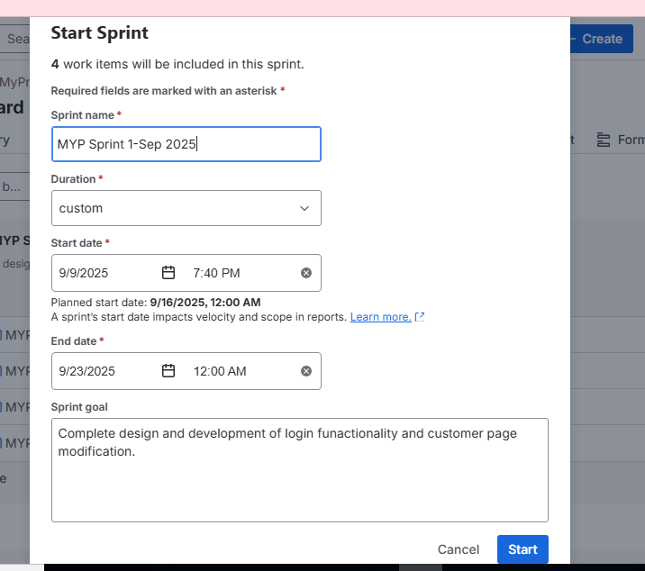

**Sprint Started(in progress):-**

